**Power BI Assignment 5**

1. **Explain DAX.**

Data Analysis Expressions (DAX) is a formula expression language used in Analysis Services, Power BI, and Power Pivot in Excel. DAX formulas include functions, operators, and values to perform advanced calculations and queries on data in related tables and columns in tabular data models. DAX is a collection of functions, operators, and constants that can be used in a formula, or expression, to calculate and return one or more values. Stated more simply, DAX helps you create new information from data already in your model.With the help of the DAX language, analysts can discover new ways to calculate data values they have and come up with fresh insights.

key points about DAX which will help you understand the concept better.

* DAX is a functional language i.e. its complete code is always a function. An executable DAX expression may contain *conditional statements, nested functions, value references,* etc.
* DAX formulas have two primary data types; **Numeric**and **Non-numeric** or Others. The numeric data type includes *integers, decimals, currency,* etc. Whereas, the non-numeric consists of*strings and binary objects*.
* DAX expressions are evaluated from the innermost function going to the outermost one at the last. This makes formulating of a DAX formula important.

You can use values of mixed data types as inputs in a DAX formula and the conversion will take place automatically during execution of the formula. The output values will be converted into the data type you instructed for the DAX formula.

1. **Explain datasets, reports, and dashboards and how they relate to each other?**

ANS- A data set is an ordered collection of data. As we know, a collection of information obtained through observations, measurements, study, or analysis is referred to as [data](https://byjus.com/maths/introduction-to-data/). It could include information such as facts, numbers, figures, names, or even basic descriptions of objects. For our study, data can be organized in the form of graphs, charts, or tables. Through data mining, data scientists assist in the analysis of gathered data.

A dataset is a set of numbers or values that pertain to a specific topic. A dataset is, for example, each student’s test scores in a certain class. Datasets can be written as a list of integers in a random order, a table, or with curly brackets around them. The data sets are normally labelled so you understand what the data represents, however, while dealing with data sets, you don’t always know what the data stands for, and you don’t necessarily need to realize what the data represents to accomplish the problem.

|  |  |  |
| --- | --- | --- |
| **Item** | Dashboard | **Reports** |
| Pages | Dashboards are created on only one page | Can be created in one or more pages |
| Data sources | Dashboards are created from multiple datasets or **reports**. | Reports are created from a single dataset |
| Visualization | Dashboards always concentrate on building insights into the data by using graphs, attractive visuals, charts, etc. | Reports are not concentrated on the visualization part of the data rather it looks to create summary pages. |
| Available in Power BI Desktop | Dashboards can not be created in Power BI Desktop | Reports can be built and viewed in Power BI Desktop. |
| Filters and Slicers | You cant add Slicers and Filters as Dashboards are limited to a single page. | In reports, we can use many different ways to filter, highlight, and slice. |
| User Interactivity | **Dashboards** allow a user to pin visuals from different **reports** and datasets onto a single canvas, making it simple to group what’s essential to the user. | **Reports** are more focused on being able to visualize and apply transformations to a single dataset. |

1. **How reports can be created in power BI, explain two ways with Navigation of each.**

## Import the Excel file

This method of creating a report starts with a file and a blank report canvas. If you want to follow along, download the [Retail Analysis sample Excel file](https://go.microsoft.com/fwlink/?LinkId=529778) and save it to your computer or to OneDrive for work or school.

1. 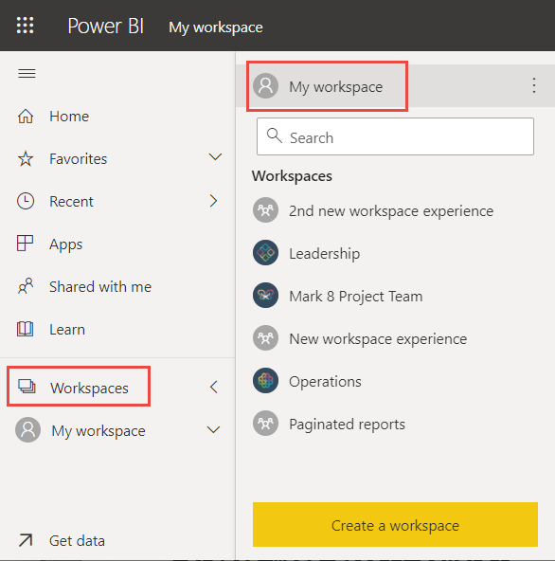In the navigation pane, select **My Workspace**.
2. From the bottom of the nav pane, select **Get data**.

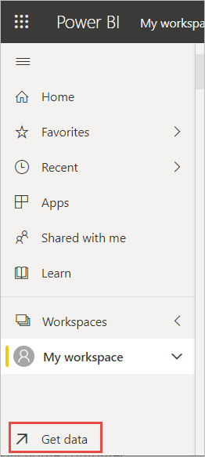

1. Select **Files** and navigate to the location where you saved the Retail Analysis sample.

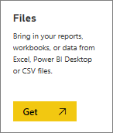

1. For this exercise, select **Import**.

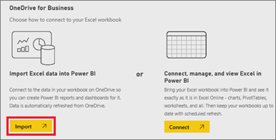

1. Select **Open**.

Once the Excel file is imported, it's listed as a dataset in the workspace list.

1. 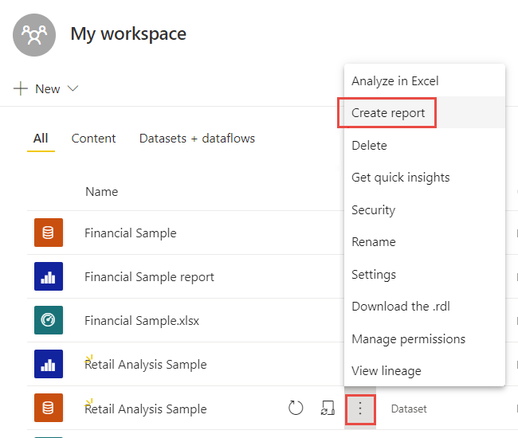Select **More options (...)** next to the dataset, and select **Create report**.
2. The report editor opens.

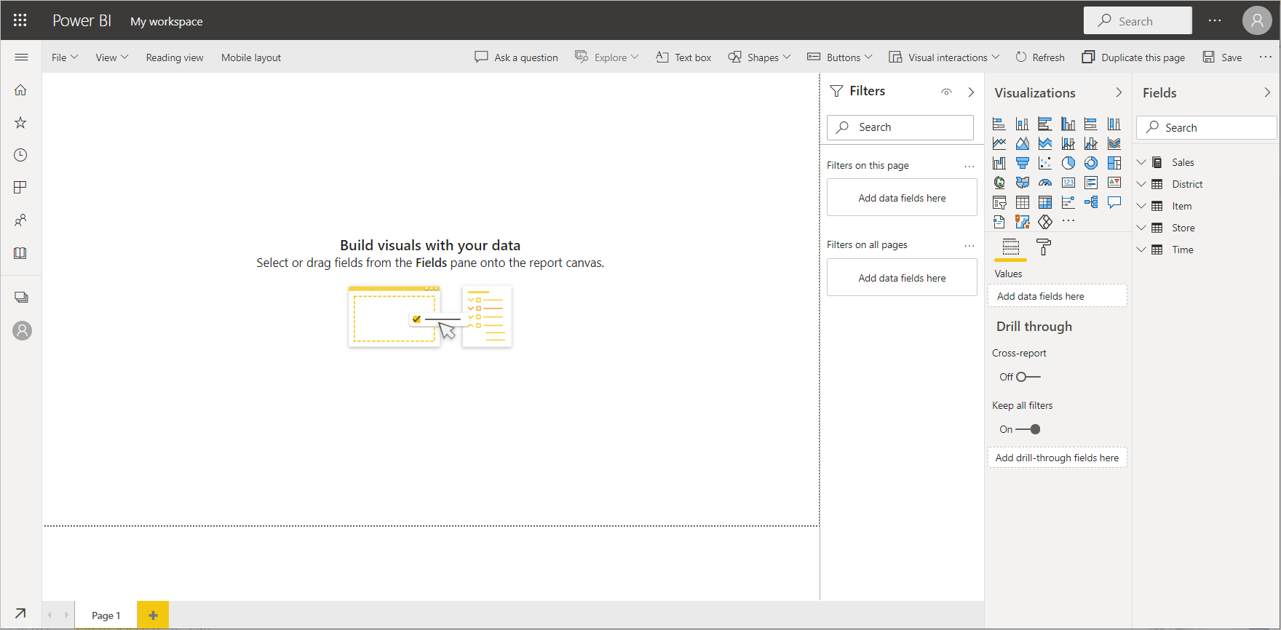

**Tip**

Select the menu icon to hide the navigation pane, to give you more room.

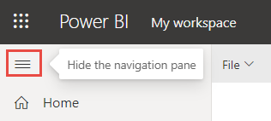

## Add a Radial Gauge to the report

Now that our dataset is imported, let's start answering some questions. Our Chief Marketing Officer (CMO) wants to know how close we are to meeting this year's sales goals. A Gauge is a [good visualization choice](https://learn.microsoft.com/en-us/power-bi/visuals/power-bi-report-visualizations) for displaying this type of information.

1. In the Fields pane, select **Sales** > **This Year Sales** > **Value**.

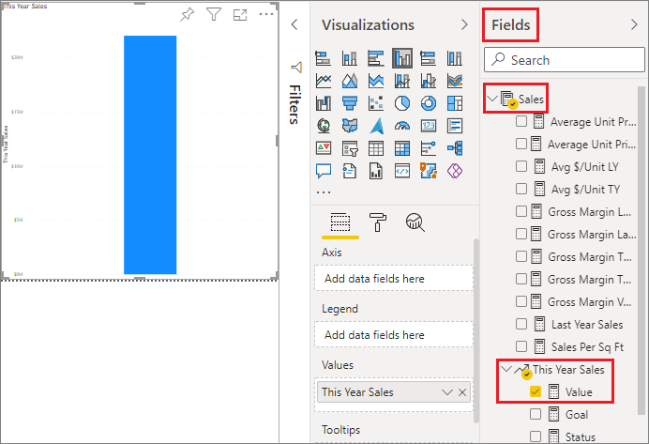

1. Convert the visual to a Gauge by selecting the Gauge template Gauge icon from the **Visualizations** pane.

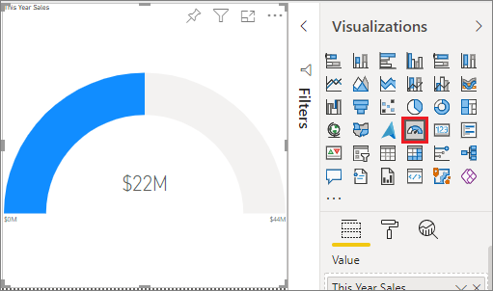

1. Drag **Sales** > **This Year Sales** > **Goal** to the **Target value** well. Looks like we're very close to our goal.

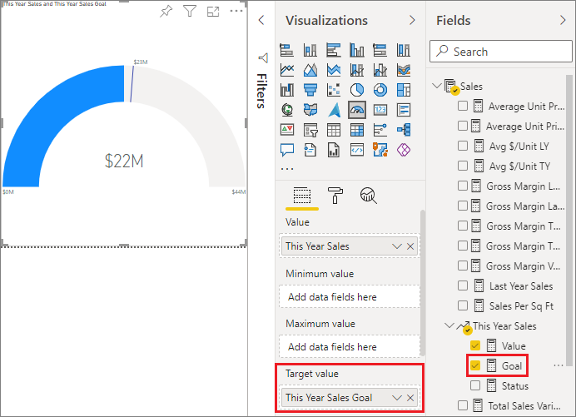

1. Now would be a good time to save your report.

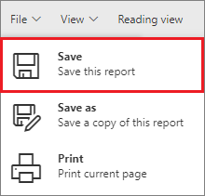

## Add an area chart and slicer to the report

Our CMO has some additional questions for us to answer. They'd like to know how sales this year compare to last year. And, they'd like to see the findings by district.

1. First, let's make some room on our canvas. Select the Gauge and move it into the top-right corner. Then grab and drag one of the corners and make it smaller.
2. Deselect the gauge. In the Fields pane, select **Sales** > **This Year Sales** > **Value** and select **Sales** > **Last Year Sales**.

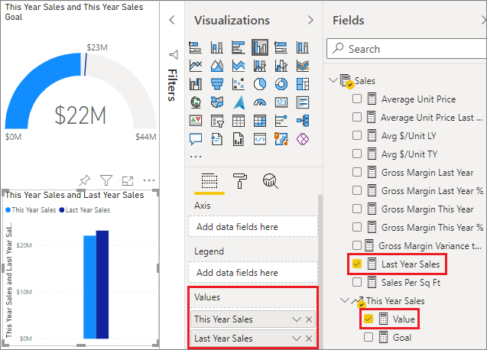

1. Convert the visual to an Area chart by selecting the Area chart template chart icon from the **Visualizations** pane.
2. Select **Time** > **Period** to add it to the **Axis** well.

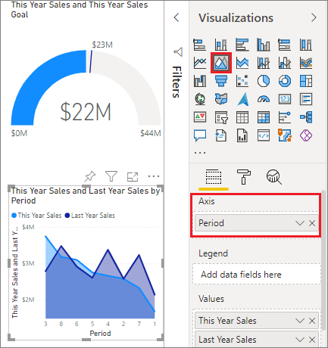

1. To sort the visualization by time period, select the ellipses and choose **Sort by Period**.
2. Now let's add the slicer. Select an empty area on the canvas and choose the Slicer Slicer icon template. We now have an empty slicer on our canvas.

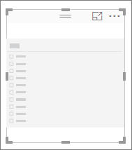

1. From the Fields pane, select **District** > **District**. Move and resize the slicer.

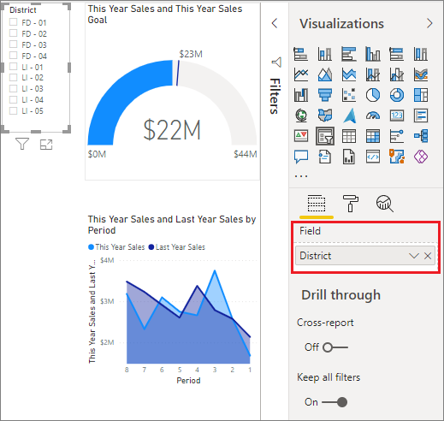

1. Use the slicer to look for patterns and insights by District.



Continue exploring your data and adding visualizations. When you find especially interesting insights, [pin them to a dashboard](https://learn.microsoft.com/en-us/power-bi/create-reports/service-dashboard-create).

# Create a report quickly from a SharePoint list or library

There's a new way to create reports quickly from data in SharePoint lists or libraries. Power BI automatically generates the visuals for you. Microsoft List and SharePoint list or library users can explore their data with just a few clicks.

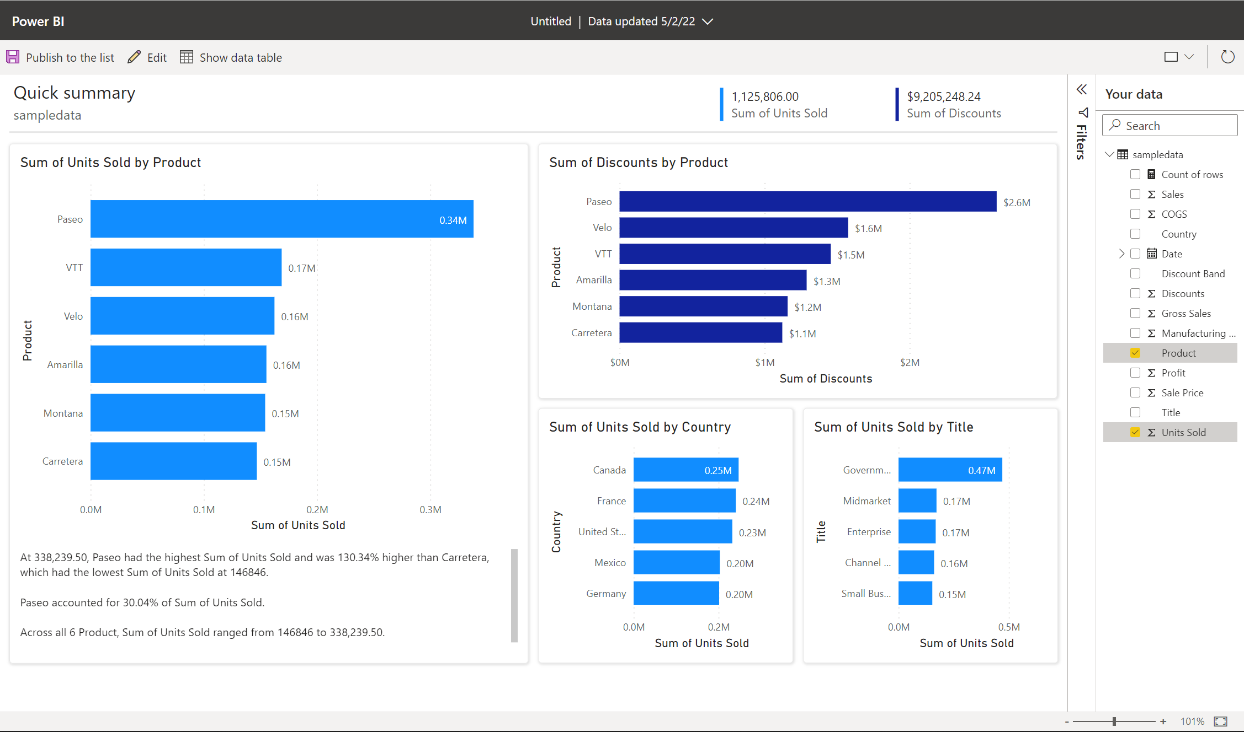

New to creating in Power BI? Try reading [Reports in Power BI](https://learn.microsoft.com/en-us/power-bi/consumer/end-user-reports) for some quick background information.

If you use Power BI Desktop, you can also [create a report on a SharePoint List in Power BI Desktop](https://learn.microsoft.com/en-us/power-bi/connect-data/desktop-sharepoint-online-list).

## Visualize in Power BI

In a SharePoint list or library, select **Integrate** > **Power BI** > **Visualize the list** or **visualize the library**.

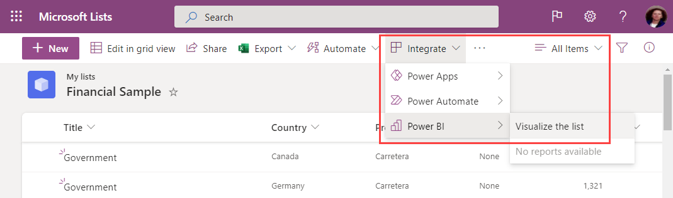

A new browser tab opens with an automatically generated report showing interesting insights based on your data.

Changing the data you see in the report is easy. In the **Your Data** pane, add or remove fields from the report. Select and deselect fields to update what you want to measure and analyze. Power BI automatically adds or removes charts to show the new combinations. Read through [Interact with autogenerated "quick" reports](https://learn.microsoft.com/en-us/power-bi/create-reports/service-interact-quick-report) to see the full capabilities of this autogenerated report.

To switch to a full edit experience, select the **Edit** button in the menu bar.

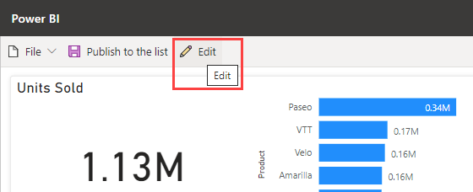

Be aware though, that once you save the report in the full edit experience, you can't go back to the quick edit view. Power BI reminds you of this when you select **Edit**.

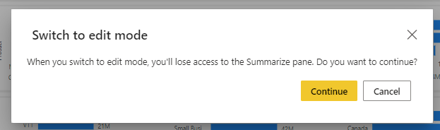

## Publish the report

To share the insights you find with others on your team, you can publish the report back to the list or library using the **Publish to the list** or **publish to the library** button in the app bar.

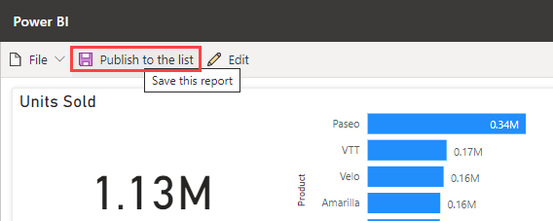

Name your report and confirm you’re ready to publish back to the list or library. Once it's published, everyone who has access to the list or library can open the report, and see all the data in the report. Learn more about [list permissions in SharePoint Server](https://learn.microsoft.com/en-us/sharepoint/sites/user-permissions-and-permission-levels#list-permissions).

The reports you share in this way aren't visible in the Power BI service. Instead, to make it easy for other list users to find, these published reports are on the same **Integrate** menu of the list or library.

If you make changes to the report, use **Publish to the list** or **publish to the library** again to save your changes. Use the **Delete** button to remove the report from the list or library for everyone.

## Refresh visuals

The data in the report will update regularly to stay in sync with the list or library. After a refresh, use the **Refresh visuals** button in the ribbon to update the visuals. Data refresh is limited to once every 3 hours. If the list or library has been updated with new data or metadata, such as an updated list or library name, after the most recent data refresh, these changes will not be reflected in the report until the next refresh.

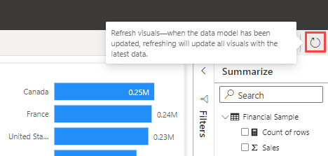

## Licenses

Anyone can use the **Visualize the list** or **visualize the library** feature to explore their list or library data. You need a Power BI Pro license to enter the full edit experience, publish reports, access reports that others have published, or delete reports. Your report readers also need a Power BI Pro license. If you don’t currently have a Pro license, you can [buy a Power BI Pro license or start a free trial](https://learn.microsoft.com/en-us/power-bi/fundamentals/service-self-service-signup-purchase-for-power-bi).

## Considerations and limitations

* Reports are published back to the list or library at the SharePoint data access level of the report creator. Row-level security (RLS) isn't supported for reports created using this method.
* Because report readers also need a Power BI Pro license, anyone who can read your report can also edit it.
* Currency formatting is not currently supported. Currency fields will show up with the $ symbol.
* If your list or document library has folders, only data in the root folder will be visualized.
* Very large lists may be slow or may time out altogether.
* This feature isn't supported for guest users in a tenant.
* Within SharePoint libraries, this option will only show on the root of the document library.
* The reports and datasets created through this SharePoint experience are stored in special, system-generated workspaces hosted in shared capacity. Users aren't meant to access these workspaces outside of the SharePoint experience.

1. **How to connect to data in Power BI? How to use the content pack to connect to google analytics? Mention the steps.**

## Launch Power BI Desktop

Once you install Power BI Desktop, launch the application so it's running on your local computer. You're presented with a Power BI tutorial. Follow the tutorial or close the dialog to start with a blank canvas. The canvas is where you create visuals and reports from your data.

[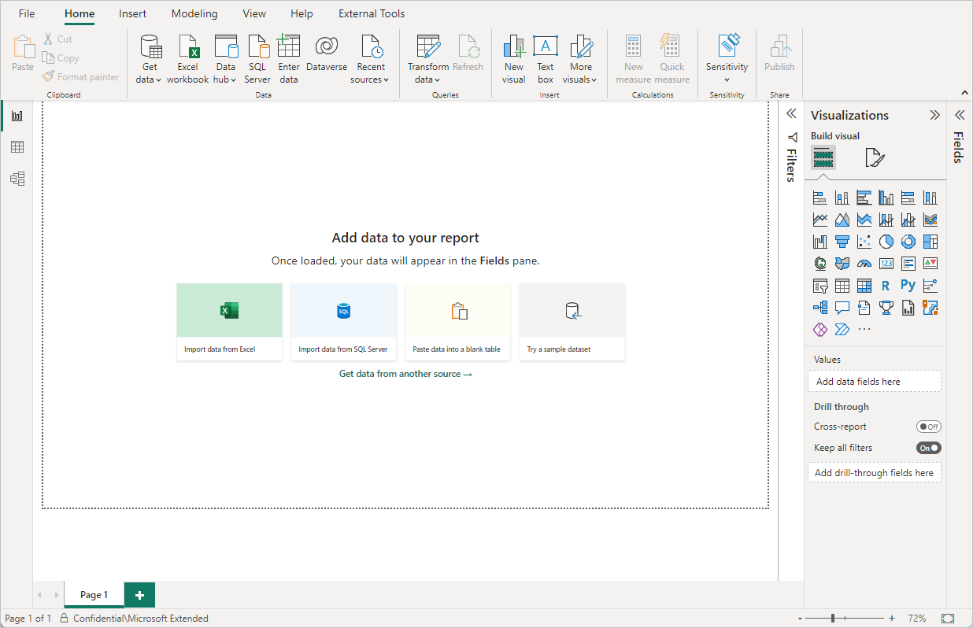](https://learn.microsoft.com/en-us/power-bi/connect-data/media/desktop-quickstart-connect-to-data/qs-connect-data_01.png#lightbox)

## Connect to data

With Power BI Desktop, you can connect to many different types of data. These sources include basic data sources, such as a Microsoft Excel file. You can connect to online services that contain all sorts of data, such as Salesforce, Microsoft Dynamics, Azure Blob Storage, and many more.

To connect to data, from the **Home** ribbon select **Get data**.

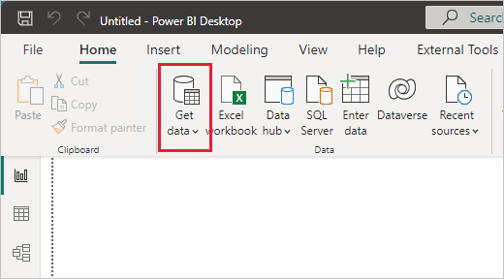

The **Get Data** window appears. You can choose from the many different data sources to which Power BI Desktop can connect. In this quickstart, use the Excel workbook that you downloaded in [Prerequisites](https://learn.microsoft.com/en-us/power-bi/connect-data/desktop-quickstart-connect-to-data#prerequisites).

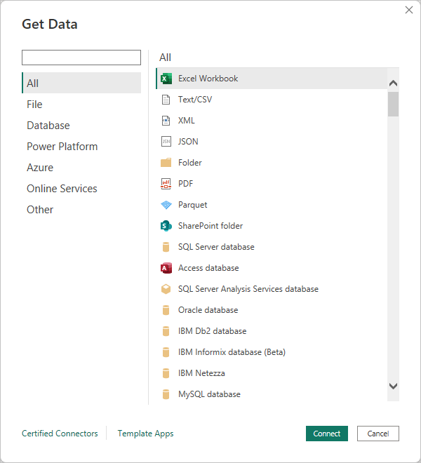

Since this data source is an Excel file, select **Excel** from the **Get Data** window, then select the **Connect** button.

Power BI prompts you to provide the location of the Excel file to which to connect. The downloaded file is called Financial Sample. Select that file, and then select **Open**.

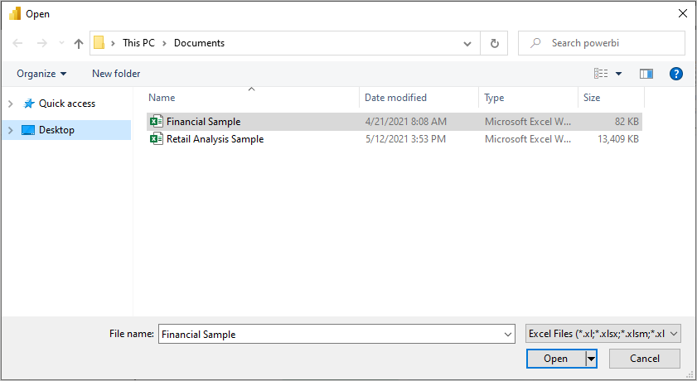

Power BI Desktop then loads the workbook and reads its contents, and shows you the available data in the file using the **Navigator** window. In that window, you can choose which data you would like to load into Power BI Desktop. Select the tables by marking the checkboxes beside each table you want to import. Import both available tables.

[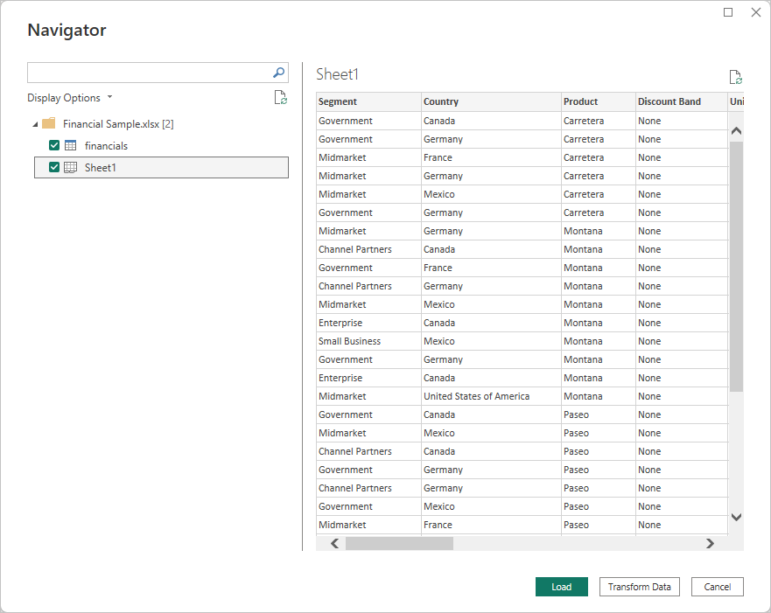](https://learn.microsoft.com/en-us/power-bi/connect-data/media/desktop-quickstart-connect-to-data/qs-connect-data_05.png#lightbox)

Once you've made your selections, select **Load** to import the data into Power BI Desktop.

## View data in the Fields pane

Once you've loaded the tables, the **Fields** pane shows you the data. You can expand each table by selecting the arrow beside its name. In the following image, the financials table is expanded, showing each of its fields.

[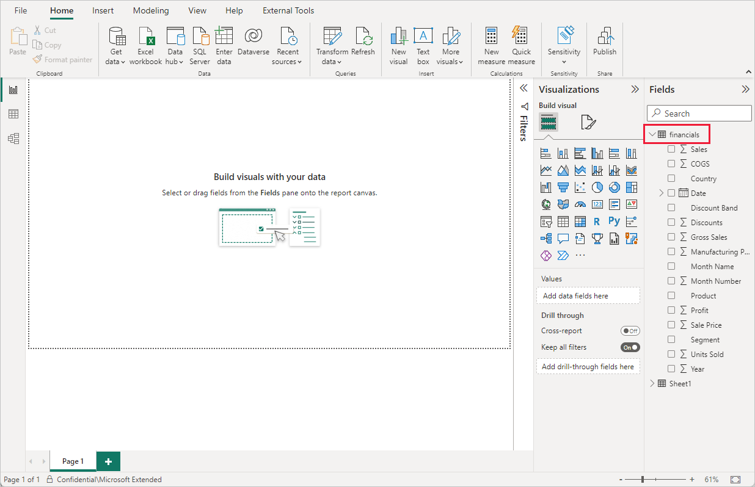](https://learn.microsoft.com/en-us/power-bi/connect-data/media/desktop-quickstart-connect-to-data/qs-connect-data_06.png#lightbox)

And that's it! You've connected to data in Power BI Desktop, loaded that data, and now you can see all the available fields within those tables.

# Use the Google Analytics connector for Power BI Desktop

You can connect to Google Analytics data using the **Google Analytics** connector. To connect, follow these steps:

1. In **Power BI Desktop**, select **Get data** from the **Home** ribbon tab.
2. In the **Get Data** window, select **Online Services** from the categories in the left pane.
3. Select **Google Analytics** from the selections in the right pane.
4. At the bottom of the window, select **Connect**.  
   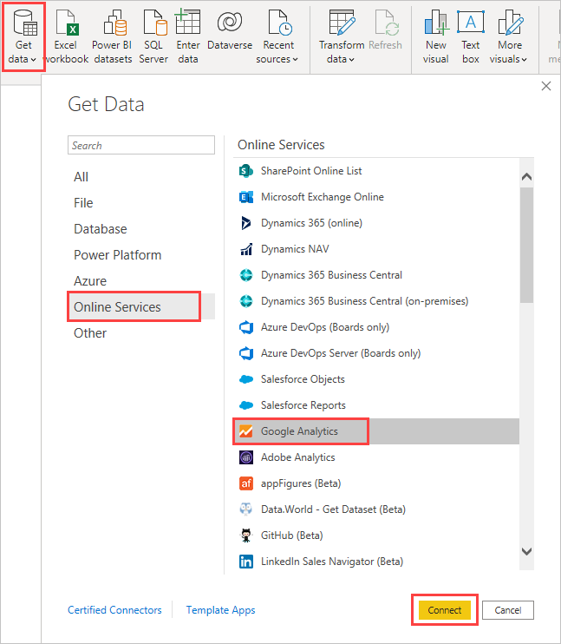

You're prompted with a dialog that explains that the connector is a third-party service, and warns about how features and availability can change over time, and other clarifications.  
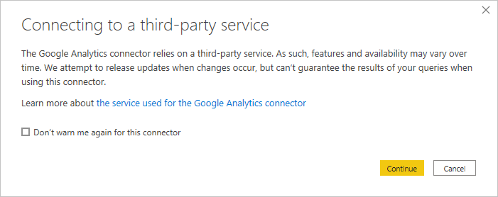

When you select **Continue**, you're prompted to sign in to Google Analytics.  
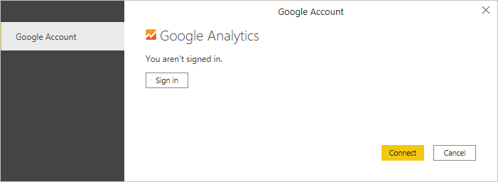

After you enter your credentials, Power BI requests offline access. This is how you use **Power BI Desktop** to access your Google Analytics data.

Once you accept, **Power BI Desktop** shows that you're currently signed in.  
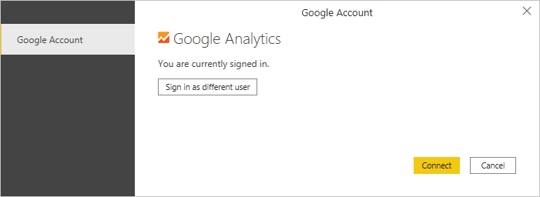

Select **Connect**, and your Google Analytics data is connected to **Power BI Desktop**, and loads the data.  
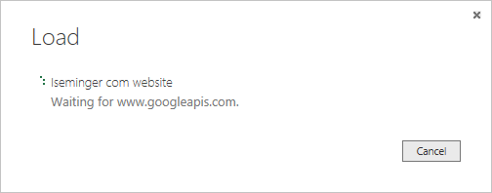

**Note**

Although we attempt to release updates in accordance with any changes, the API might change in a way that affects the results of the queries we generate. In some cases, certain queries might no longer be supported. Due to this dependency, we can't guarantee the results of your queries when you use this connector.

1. **How to import Local files in Power BI? Mention the Steps.**
2. In Power BI, click **Get Data** in the lower left screen.
3. Under **Import or Connect to Data** > **Files**, click **Get**.

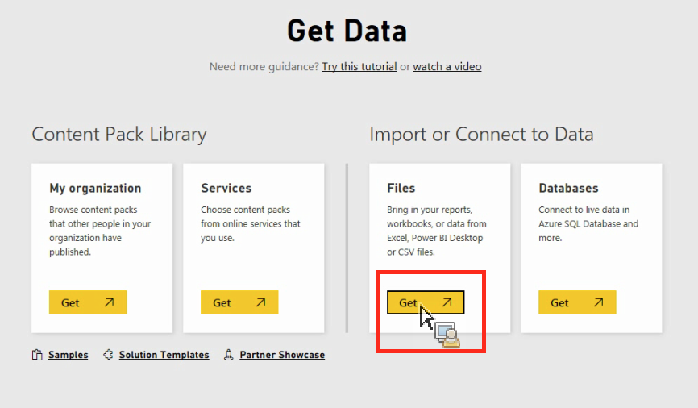

1. Click Local File.

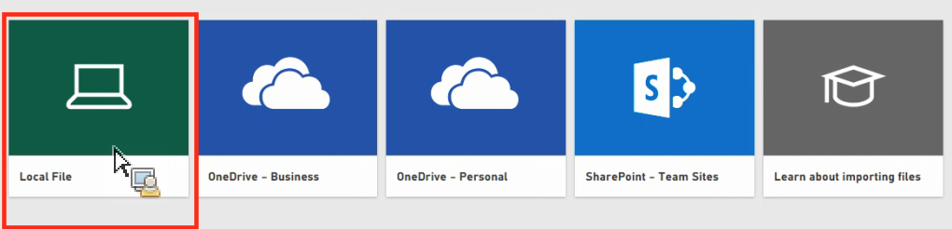

1. Choose which file to upload and click **Open**.
2. Click **Upload** under **Upload your Excel file to Power BI**.

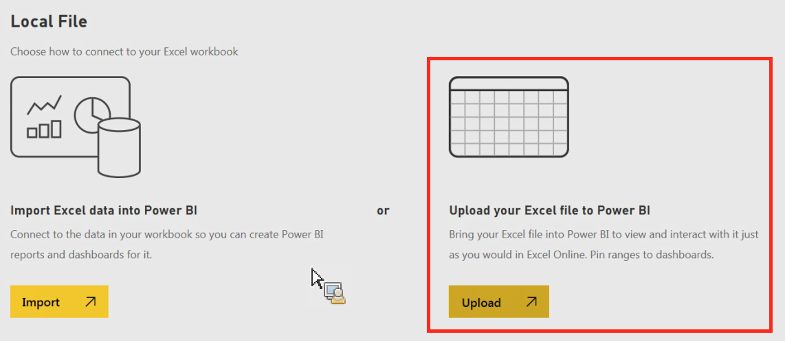

1. The message “Your file has been uploaded” should appear.
2. **In Power BI visualization, what are Reading View and Editing view?**

## Ans - Reading view

There are two modes for interacting with reports in the Power BI service: Editing view and Reading view. If you are a business user, then you are more likely to use Reading view to consume reports created by others. Editing view is used by report designers, who create the reports and share them with you. Reading view is your way to explore and interact with reports created by colleagues.

Even in Reading view, the content isn't static. You can dig in, looking for trends, insights, and other business intelligence. Slice and dice the content, and even ask it questions using your own words. Or, sit back and let your data discover interesting insights for you; send you alerts when data changes, and email reports to you on a schedule you set. All your data, any time, in the cloud or on-premises, from any device.

## Editing view

To help you navigate the Table of Contents, Editing view is required for the following actions:

* Creating, editing, renaming, sharing, and deleting reports.
* Adding, renaming, rearranging, and deleting report pages.
* Formatting reports.
* Adding visualizations, text boxes, shapes, and buttons to a report.
* Adding visual-level, page-level, and report-level filters and setting visual interactions.
* Creating refresh schedules.
* Using Q&A functionality to create visuals in reports.
* Showing data used to create the visualization.
* Setting up drillthrough.
* Duplicating a report page.
* [Using report settings](https://learn.microsoft.com/en-us/power-bi/create-reports/power-bi-report-settings) to control your readers' interactions with reports.